Open Source Graphics and Animation Tools Lab

Mid-Semester

4th March 2020

Phase-1

GIMP Project

Submitted To: Submitted By:

Dr. Durgansh Sharma Shivangini Aggarwal

Professor, Cybernetics SCS Btech CSE-OSOS 2nd year

Sap Id: 500069005

Roll no: R100218055

Contents

Creating Scooby doo: 2

Creating the Ghost 3

Creating the tree 3

Creating the bats: 4

Typography: 5

Layers of the final outcome: 6

Background layer: 6

Scooby doo layer: 6

Ghost layer: 7

Tree and bats layer: 7

Path layer: 7

Comment section layer: 8

Text layer: 8

Effects of Channel 9

Effect of channel on my gimp project: 9

Final Outcome: 13

# 

# Creating Scooby doo:

1. Opened the image that has to be traced in gimp.
2. Created a new layer. Layer fill type should be transparent.
3. Select the path tool for the tracing.
4. Draw the path around the subject that has to be traced.
5. Ctrl + Click to finish the loop/
6. Right click inside the image and make path into selection by clicking select->From path.
7. Select bucket fill tool. From change foreground color choose select color picker tool and select the part according to which the object has to colored.
8. Now fill the color on the selected part.
9. Hide the cartoon layer and you can see the colored area.
10. Now, repeat the same process and create all the feature of the subject using the same technique.

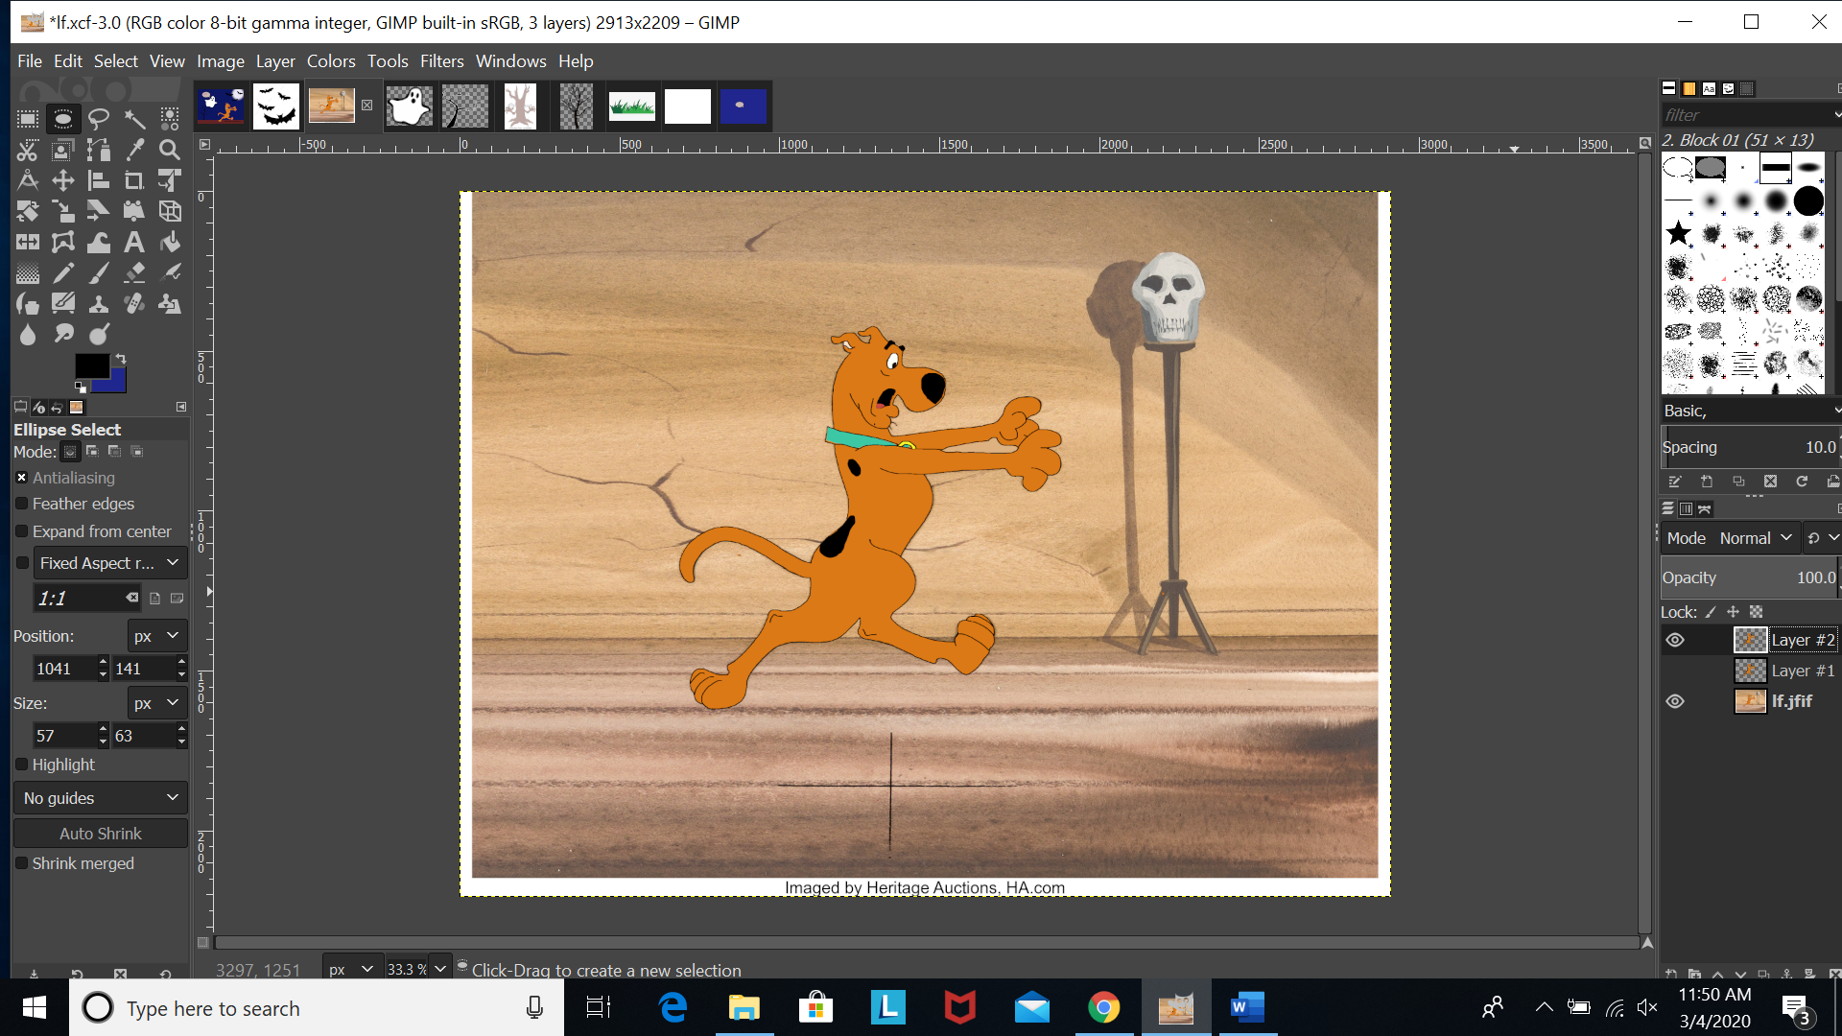

# Creating the Ghost

1.The above steps were repeated for the creation of the ghost.

1. The tracing technique was used.

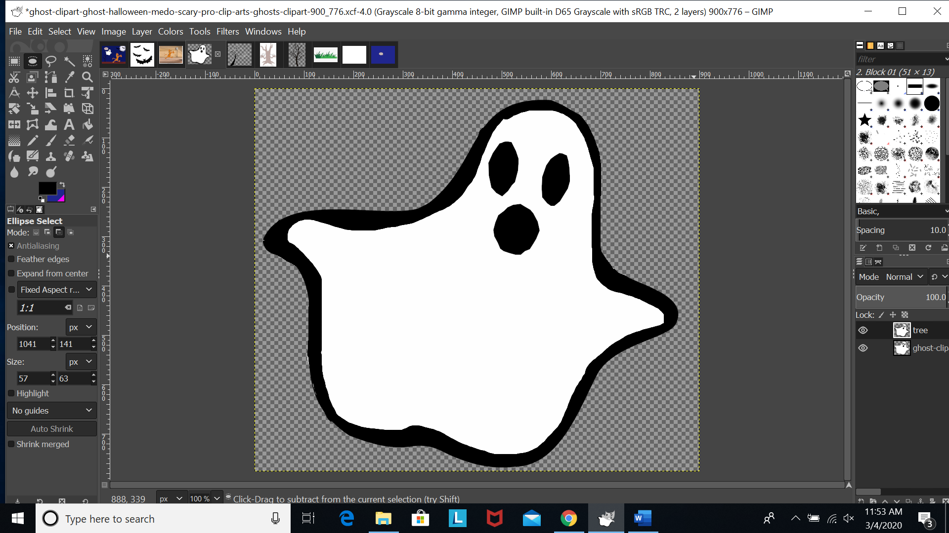

# Creating the tree

1.The above steps were repeated for the creation of the tree.

2.The tracing technique was used.

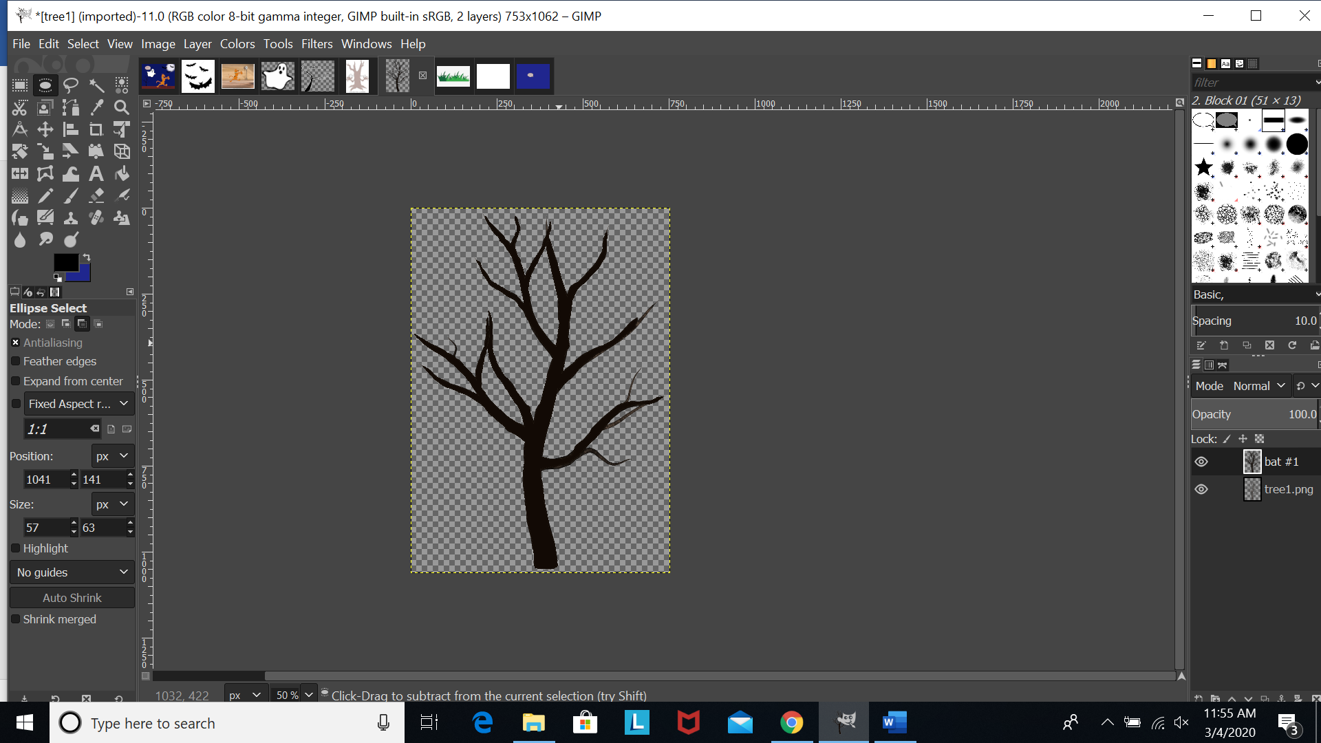

# Creating the bats:

1. The above steps were repeated for the creation of the bats.
2. The tracing technique was used.

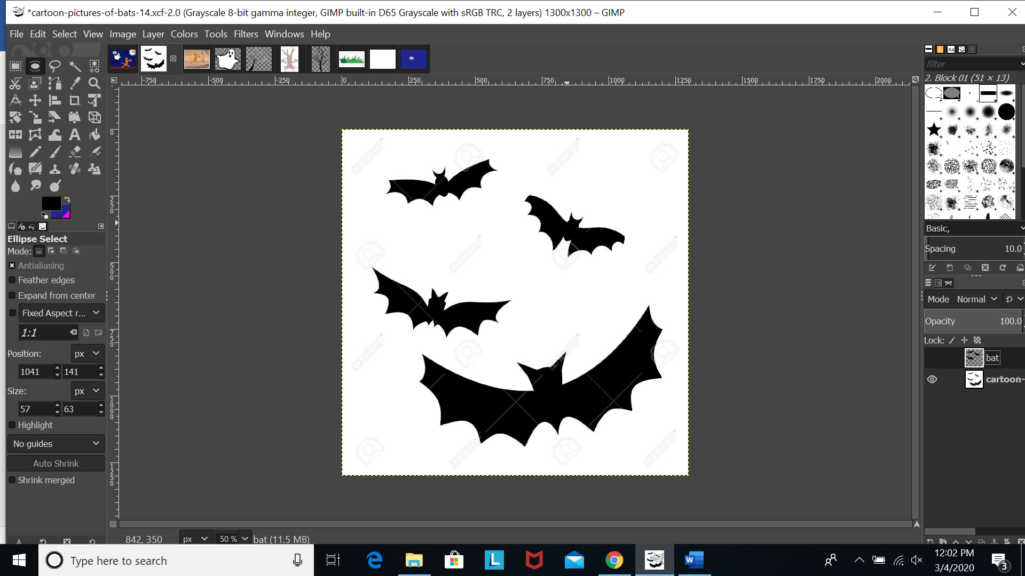

# Typography:

Scooby doo text:

Font type: Ink Free,

Font size: 62px

Font color: red

Kerning: 0

Tracing: 0

Why?

I kept kerning and tracing 0 because the space allocate for this text was less and kerning and tracing was not required.

The mystery continues text:

Font type: Sans-Serif bold

Font size: px: 90

Font color: black

Kerning: 2px

Tracing: 1px

Why?

As the text has to be highlighted and exaggerated therefore, I used kerning and tracing to make it as per requirement.

# Layers of the final outcome:

## Background layer:

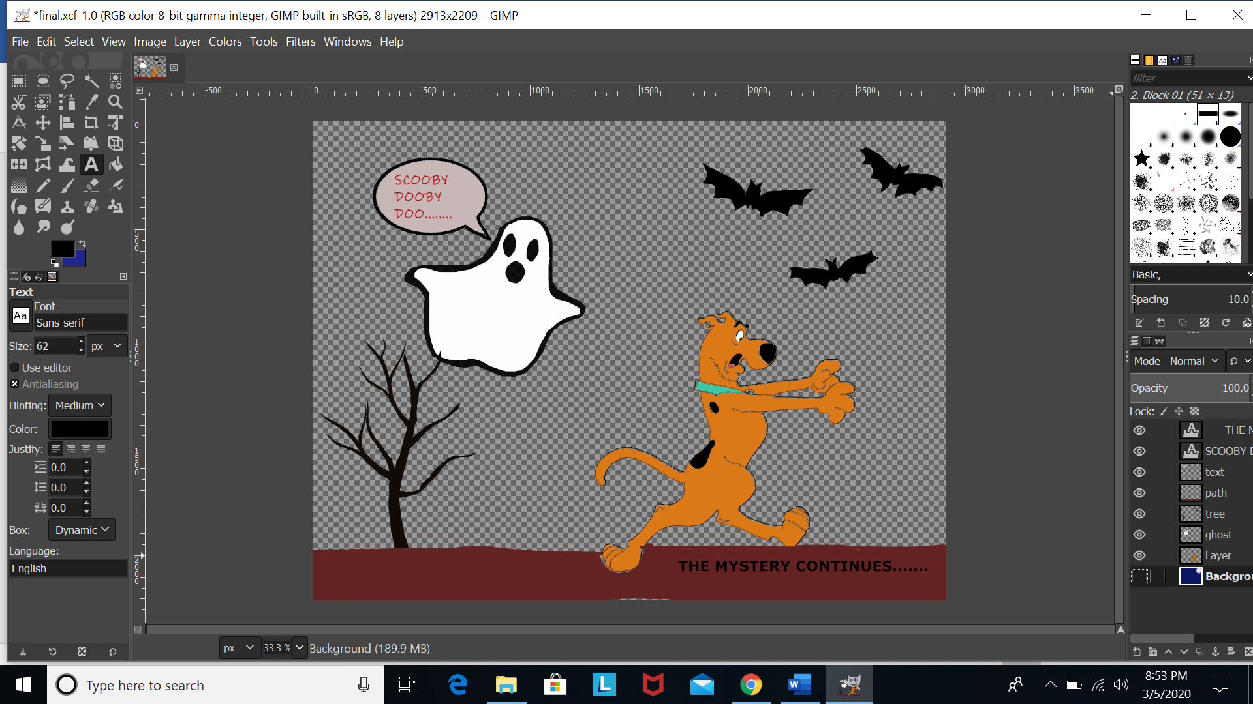

## Scooby doo layer:

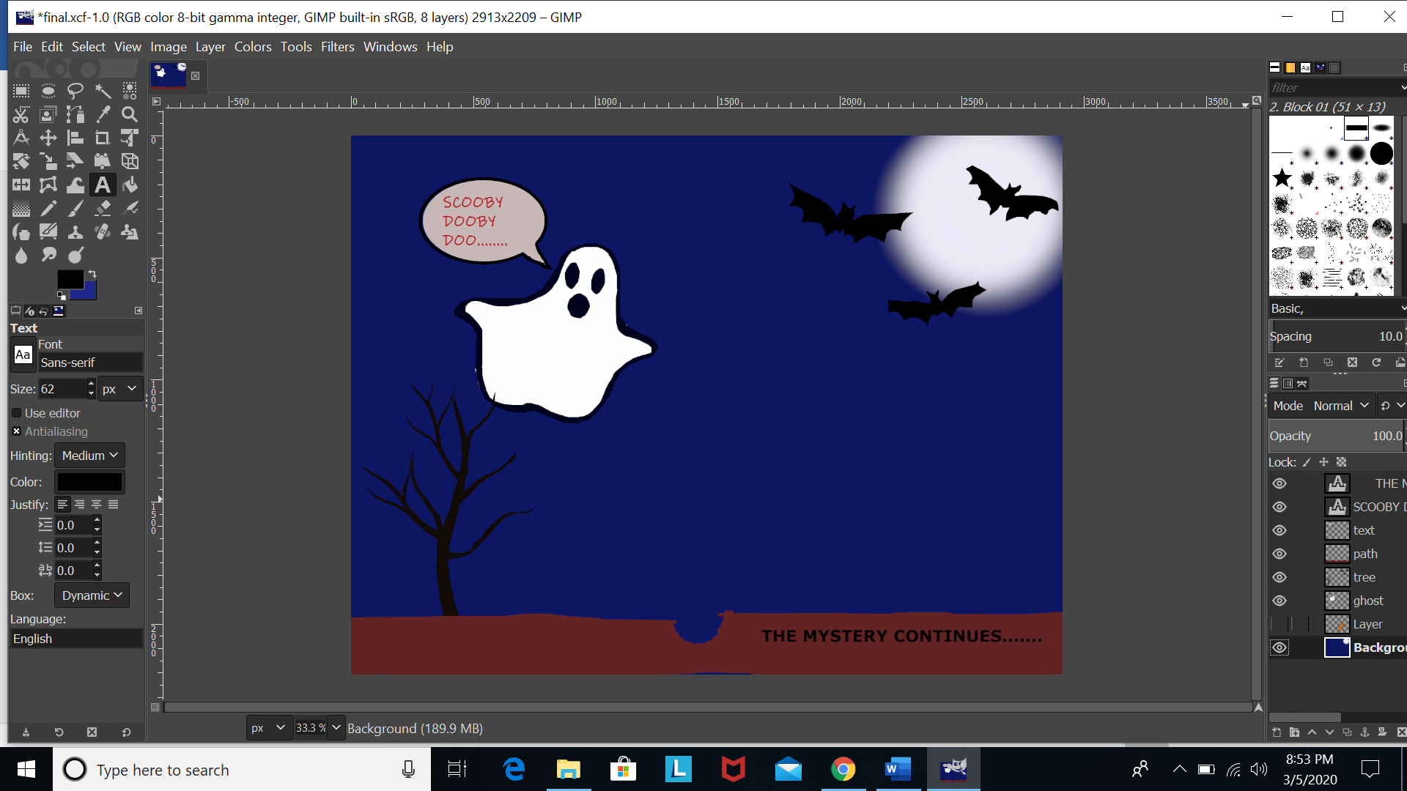

## Ghost layer:

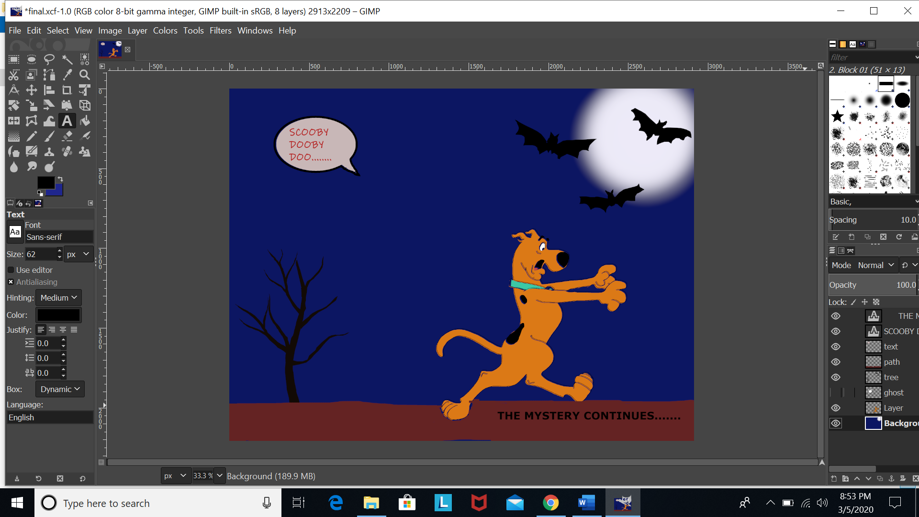

## Tree and bats layer:

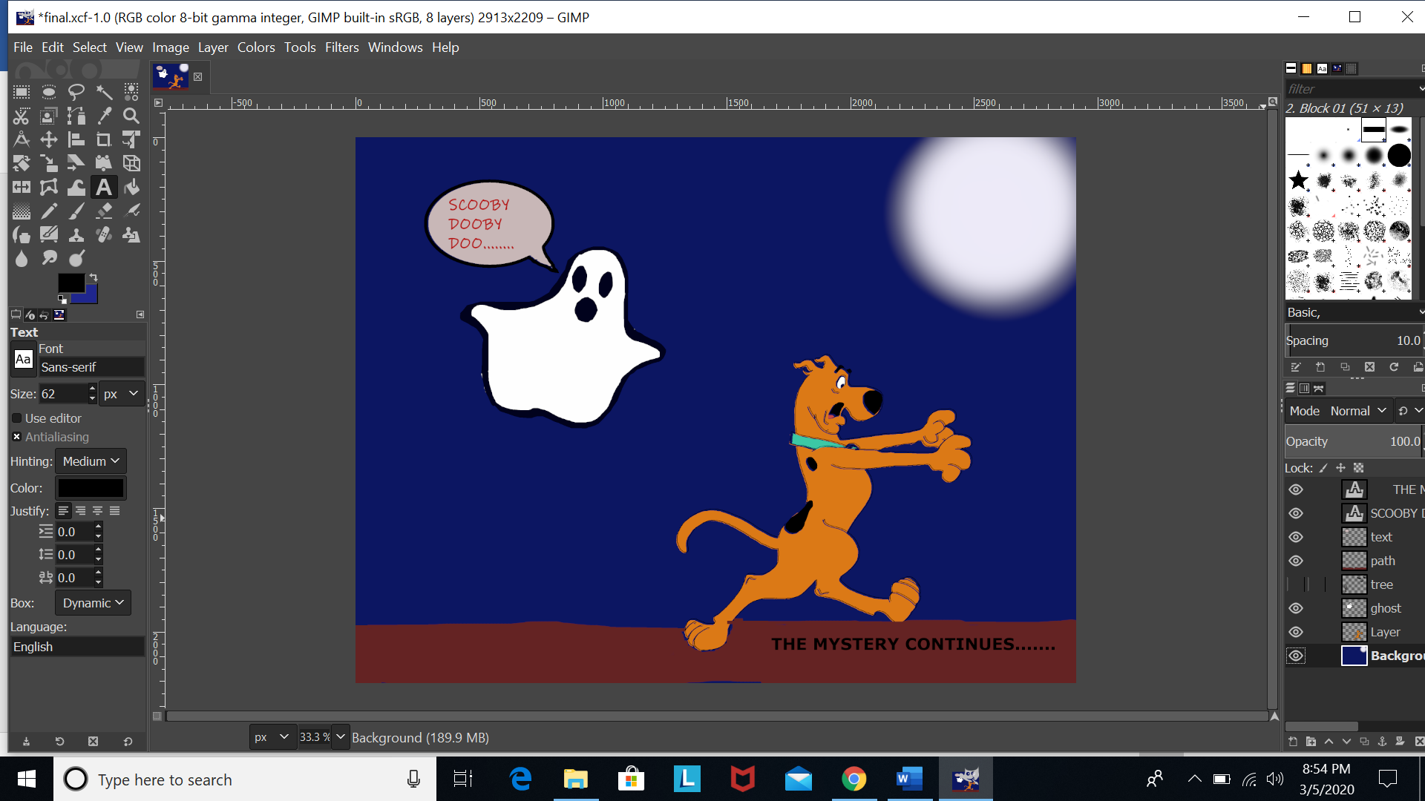

## Path layer:

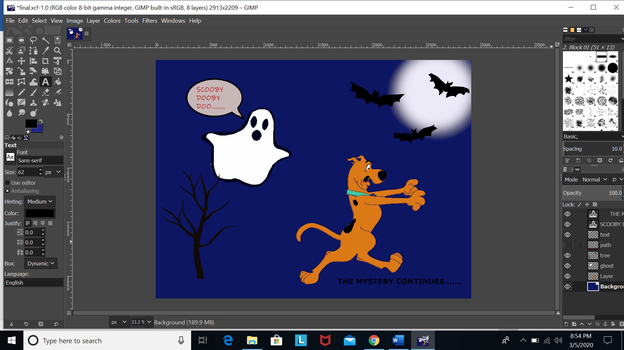

## Comment section layer:

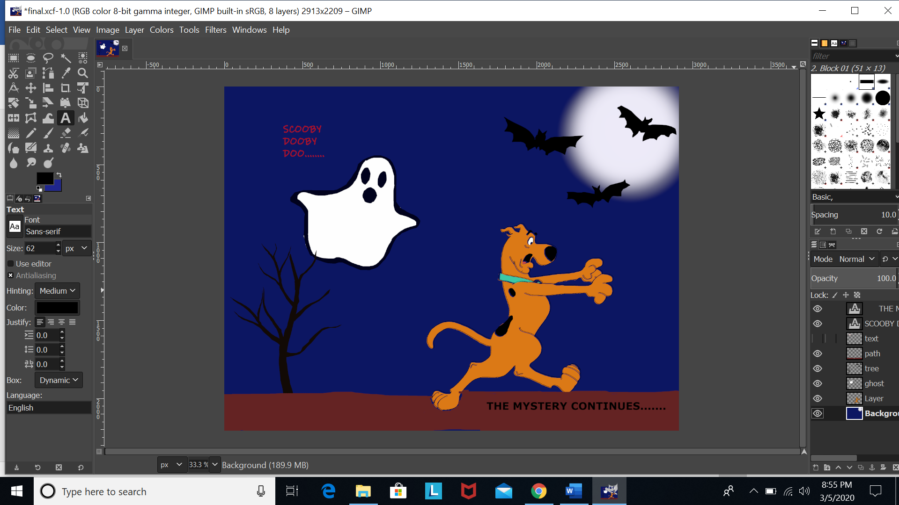

## Text layer:

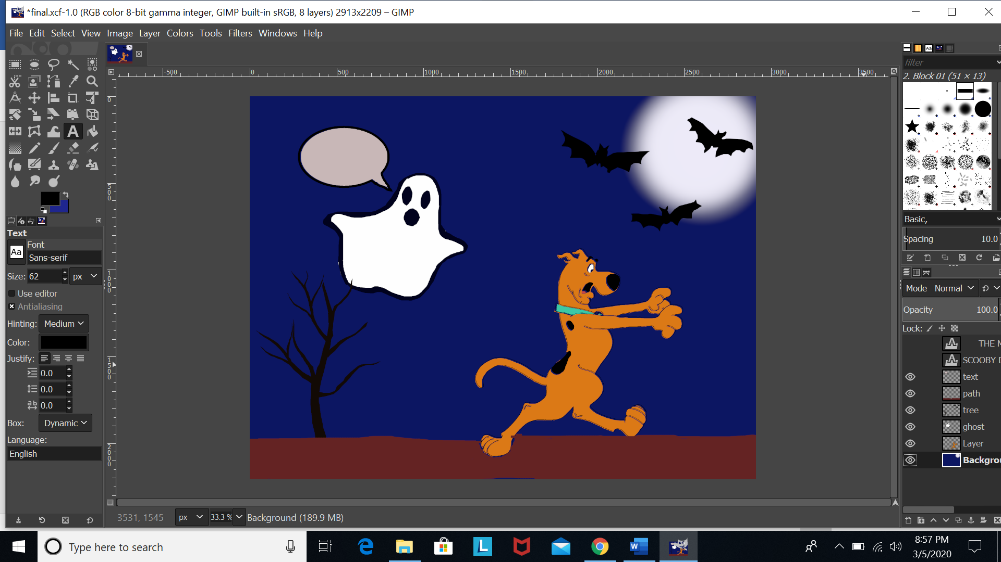

# Effects of Channel

In the standard distribution of the **GIMP**, **channels** are eight bits deep, meaning that each pixel in a layer is represented by up to 32 bits. However, there is a special development version of the **GIMP** that uses **channels** that are 16 bits deep, making for layers with pixels represented by up to 64 bits.

There are three types of channel:

1. Red
2. Green
3. Blue

## Effect of channel on my gimp project:

1. Red

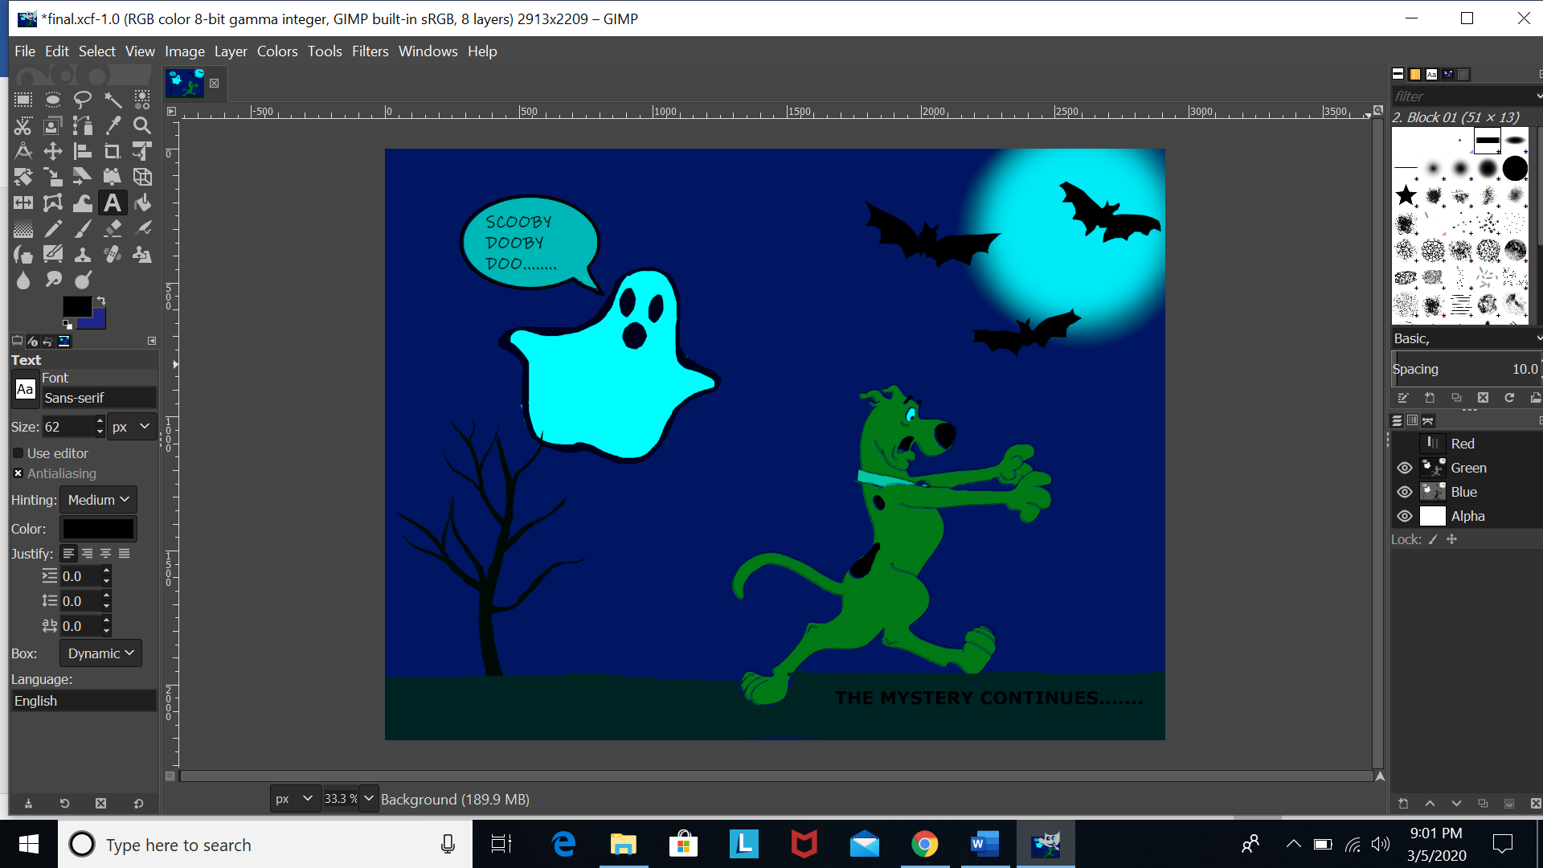

**Rgb wala option**

1. Green

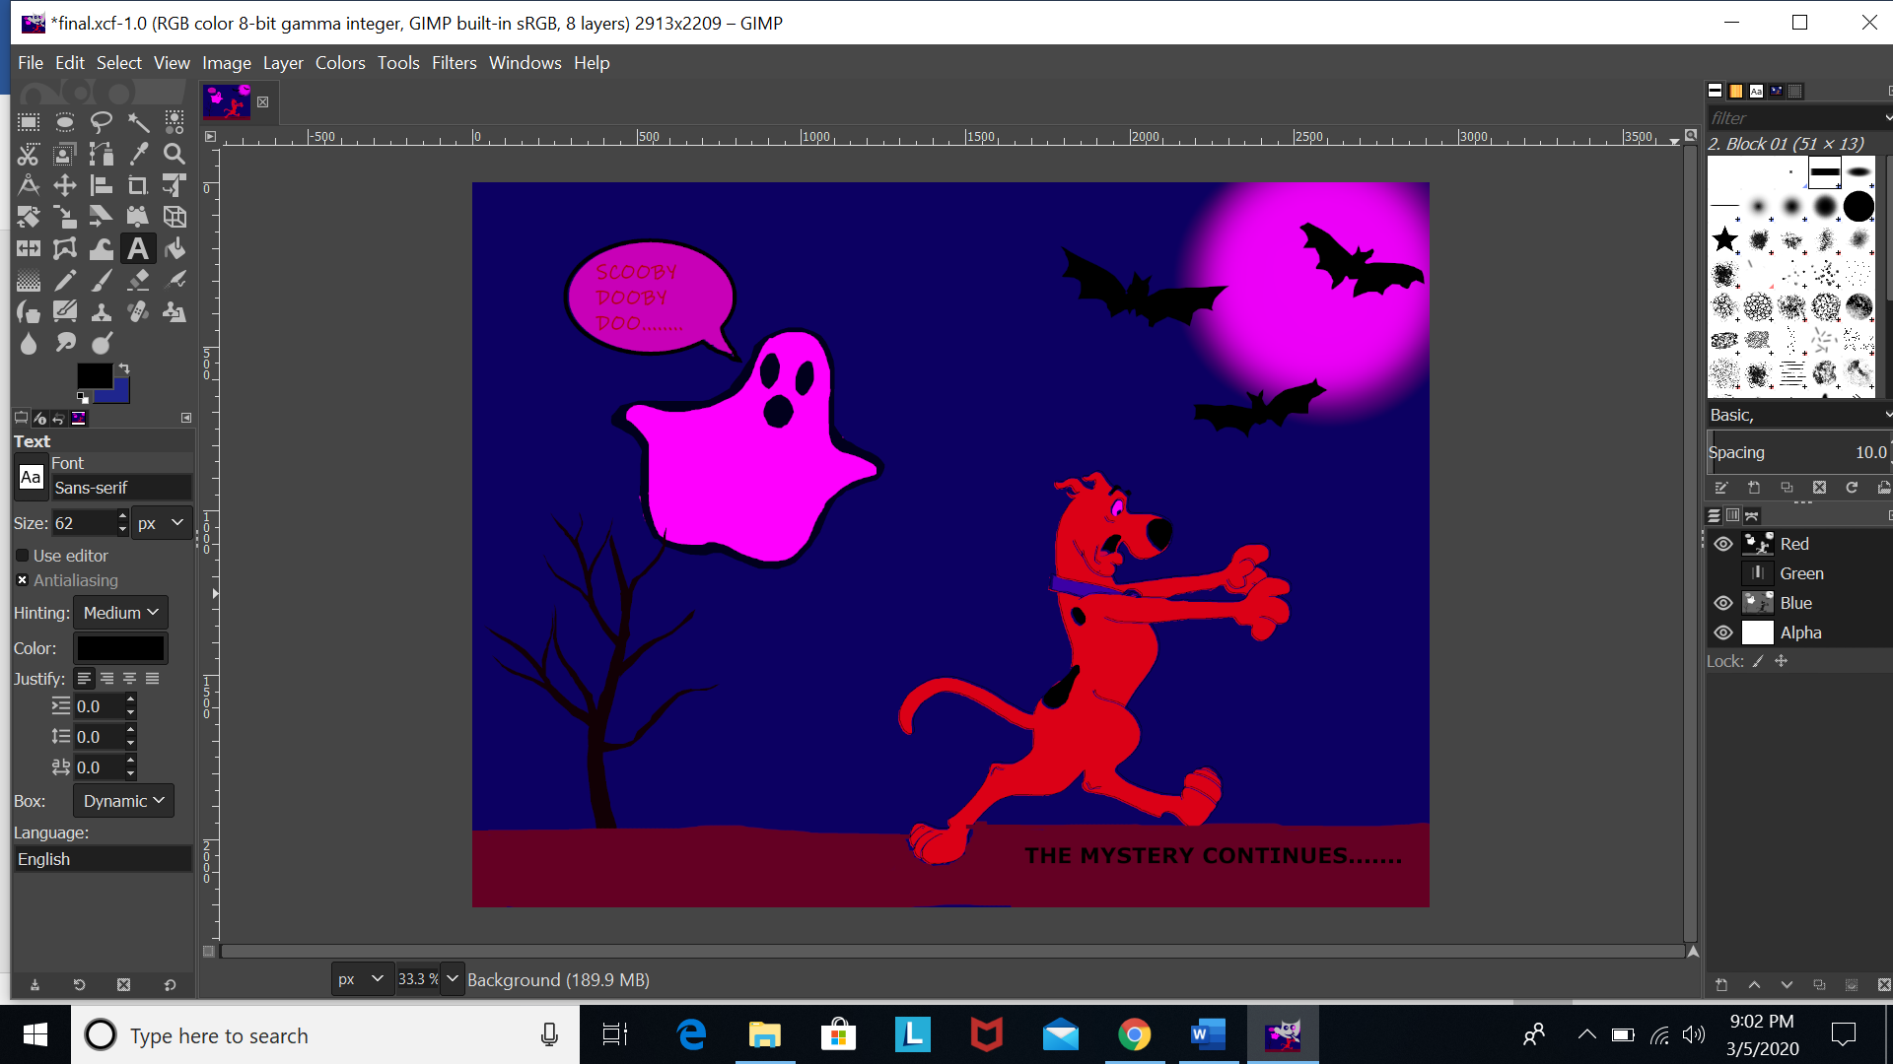

1. Blue

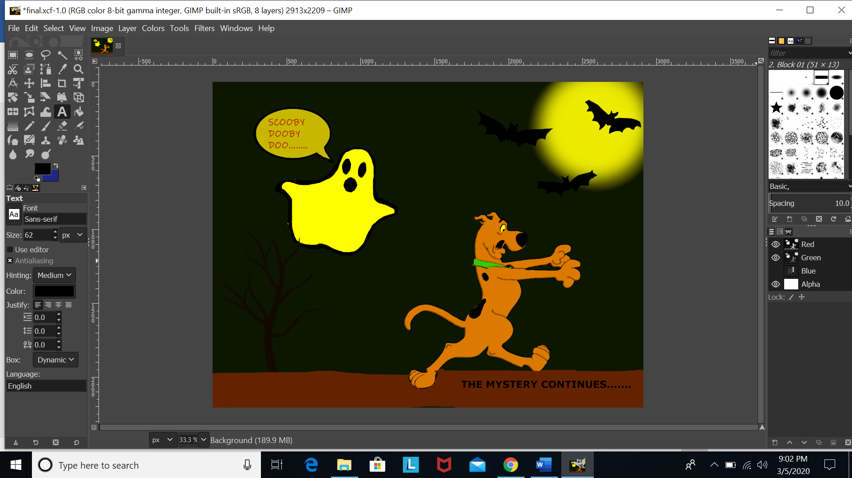

1. Red-green

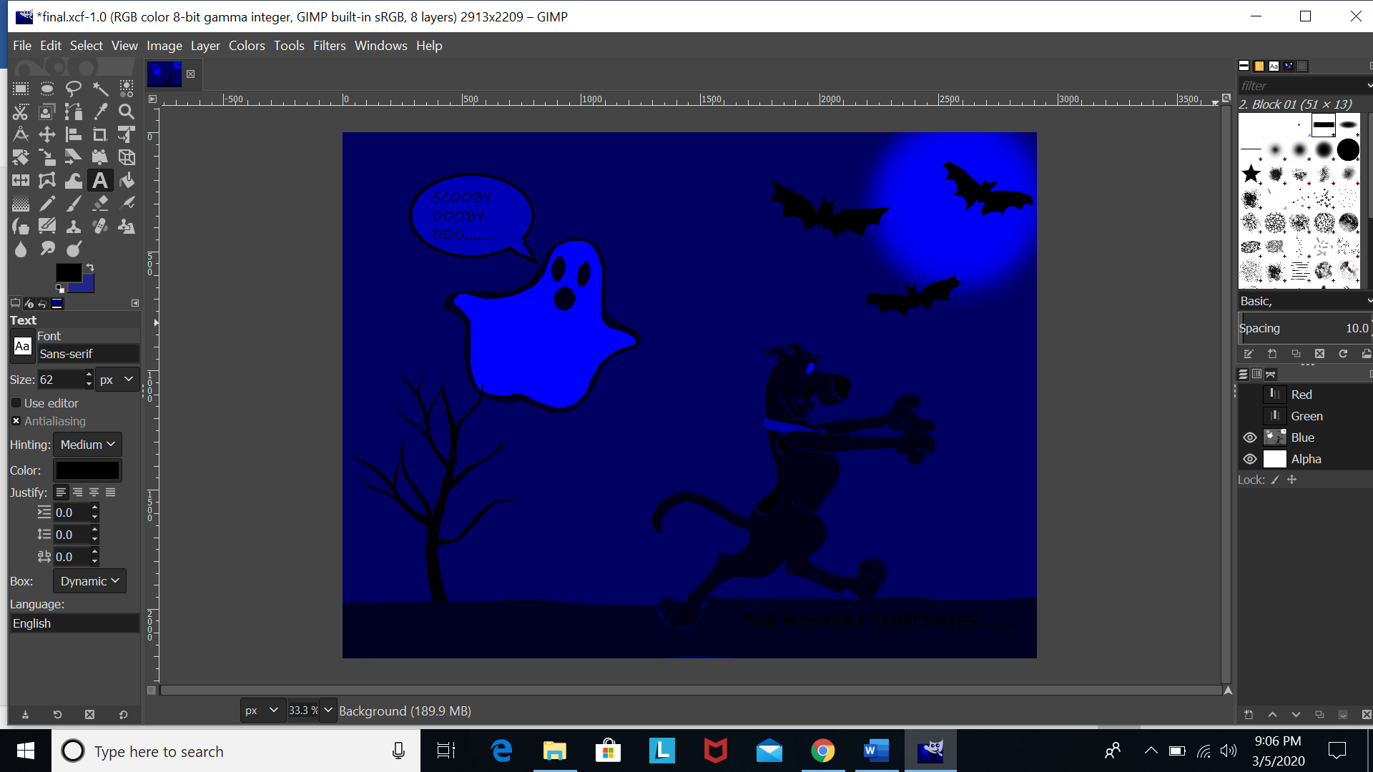

1. Green-blue

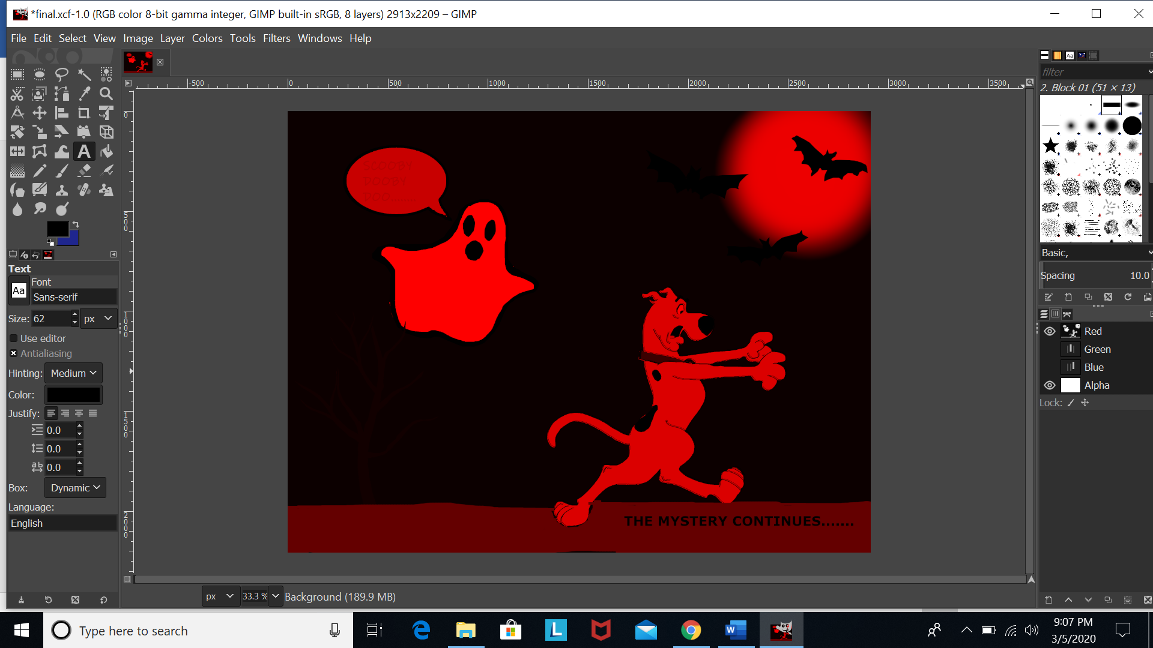

1. Red-blue

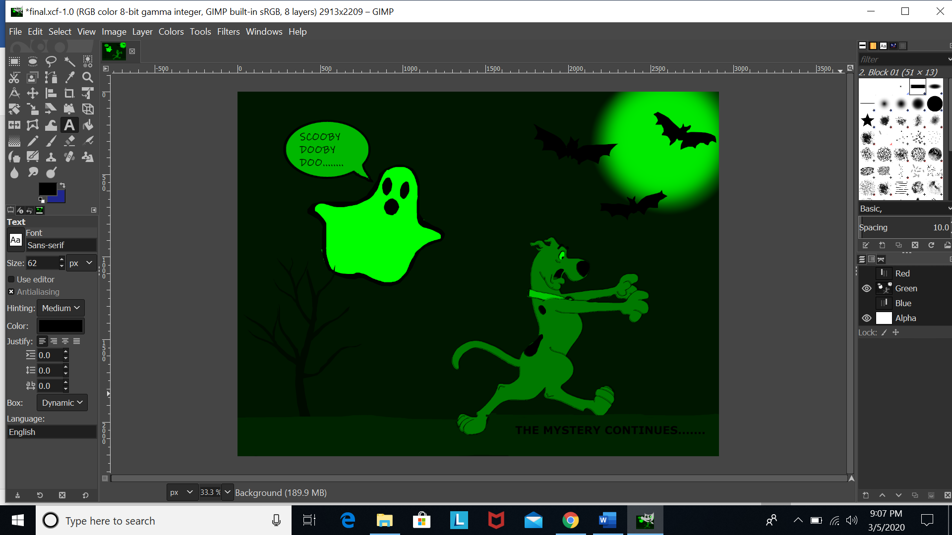

# Final Outcome:

